**MINERAL PROSPECTIVITY AND EXPLORATION TARGETING (MinProXT - 2021)**

*by*

*Author A. 1, Author B. Jr. 1, and Author C. D. 2*

*1ABC University, City, State/Region, Mail/Zip Code, Country (authors' affiliation(s) listed here)*

*2XYZ University, City, State/Region, Mail/Zip Code, Country (authors' affiliation(s) listed here)*

*E-mail: add e-mail of the corresponding author only*

**Abstract -- This document gives you guidelines for preparing the extended abstract to be submitted to the “Mineral prospectivity and Exploration Targeting (MinProXT -2021)” webinar. The extended abstract should be limited to 2 pages, including 1-2 figures. The extended abstract must contain one figure at least. Do not add tables.**

**INTRODUCTION**

This template is intended for Microsoft Word versions 6.0 or later. While using this template, please remember that you must still adhere to the general guidelines embodied in this document concerning, font size, margin size, page limits, etc. The two-page extended abstract is intended to describe the authors’ work in sufficient detail to allow its evaluation by the panel. References must be cited as Barnes et al. (2011) or (as Barnes et al. 2011).

The extended abstract should have the following sections: Abstract, Introduction, Data and/or Methods, and Results and Discussion. Optionally also Acknowledgements and/or References.

**DATA AND/OR METHODS**

Each major section begins with a heading in 11.5 pt Muli- extrabold font left justified within the column in capital letters. The paragraph spacing of the section heading line should be set for 12 pt before, and 4 pt after. For the body of your paper, use the 9.5-point Merriweather-Regular font and set your line spacing at "exactly 10.95 pt" with paragraph spacing 0 pt before and after. Subsection headings should be with 10 pt Muli-extrabold font left justified within the column with first letter capitalized.

**Equations**

If you are using Word, you can use either the Microsoft Equation Editor or the MathType add-on (http://www.mathtype.com) for equations in your paper (Insert > Object > Create New > Microsoft Equation or MathType Equation). “Float over text” should not be selected. You can also insert your equation as a figure, and this is how they are provided to the final version. We will request a high-resolution image of each equation in case your abstract is accepted.

Number equations consecutively with equation numbers as in Eq. (1). To make your equations more compact and font size readable, you may use the solidus ( / ), the exp function or similar. Remember to use parenthesis to avoid any ambiguities related to negative values and order of operations. Be sure that all the symbols in your equation are defined before the equation appears or immediately following it. Preferably locate equations as part of a sentence, as in

$\int_{ 0}^{ r_{2}}{F(r,ϕ)} dr dϕ=σr_{2}/(2μ_{0}),$ (1)

where the symbols could be explained in this sentence. Italicize symbols (*T* might refer to temperature, but T is the unit tesla). Boldface symbols in case of vector quantities. Refer to equations as “Eq. (1)”. Please confine equations to one column width and break equations at appropriate algebraic symbols.

**RESULTS AND DISCUSSION**

Figures should be within the indented space of the page and should utilize as much of the width as possible in order to maximize legibility. For text embedded in the figures use a sans serif font, such as Helvetica or Arial. Helvetica and Arial are larger and much easier to read than Times. Using 8- to 10-pt Helvetica usually results in a legible figure. Do not use any font smaller than 8-point.

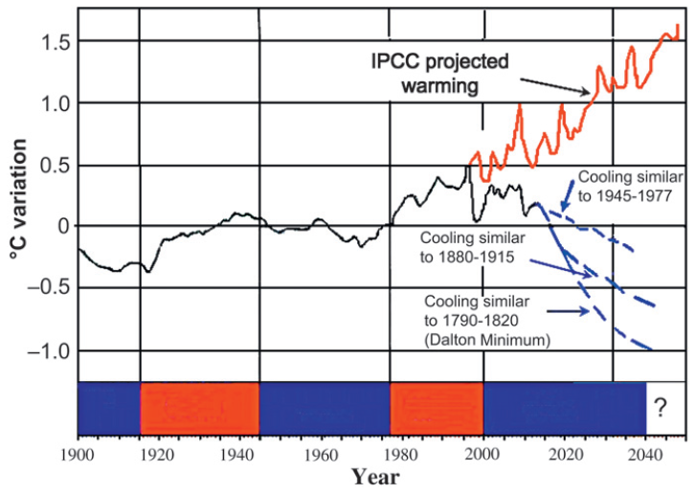

Figure 1. Figure caption text with the same font as the body text.

When referring to figures, use the format “Fig. (1)”. If the paper is accepted for presentation at the webinar, then we will request the authors to submit a high-resolution image of the Figures at a later stage. The final placement of the figure will be defined in the folding stage of proceedings publication process, but you should place the figure in the place, where you would want it to approximately be. Within Microsoft Word there are several options for placing figures within your paper. Often the easiest is to insert them between existing paragraphs allowing the figures to remain in that relative position. However, since placing figures in Word document is always an art and a highly exciting procedure, never knowing where it finally ends up, it is recommended that you nearly complete the editing of your text before inserting any figures. Remember to allow room for them, however. Then begin inserting figures starting from the beginning of your document. Do not lump all figures at the end of the paper.

**REFERENCES**

**Barnes, S. J., Fiorentini, M. L., Duuring, P., Grguric, B. A. & Perring, C. S. 2011.** The Perseverance and Mount Keith Ni deposits of the Agnew-Wiluna Belt, Yilgarn craton, Western Australia. In: Li, C., Ripley, E. (Eds) Magmatic Ni–Cu and PGE Deposits: Geology, Geochemistry, and Genesis. Reviews in Economic Geology, vol. 17, 51–88.

**SUMMARY OF THE SUBMISSION INSTRUCTIONS (THIS SECTION WILL BE DELETED IN THE ABSTRACT VOLUME)**

• The extended abstract should be of no more than two pages and must contain 1-2 figures illustrating the research.

• Please do not add tables in the extended abstract file.

• Please submit the extended abstracts as a PDF file of size no more than 5 MB.

• Email us the PDF file of the extended abstract to minproxt@gtk.fi

• The subject of the email should be: ‘Extended Abstract Submission – **Title of the Abstract**’

• We also request the authors to provide the following information in the email text:

o Name and primary affiliation of the corresponding author:

o Name and primary affiliation of the presenting author (if not the same as the corresponding author):

o Theme of the abstract: **Theme 1/Theme 2**

o Webinar preferences - Willing to present in

* Part 1 - Eastern Hemisphere Webinar: **Yes/No**
* Part 2 - Western Hemisphere Webinar: **Yes/No**

• Submission of the abstract does not guarantee acceptance. All submitted abstracts will be peer reviewed and authors of the accepted abstracts will be notified by 20th August 2021. The list of the accepted abstracts will be displayed on the webpage.

• Due to the large volume of abstracts we will not be able to notify all the authors if their abstracts are not accepted. Hence please visit our website on/after 20th August 2021 to check the list of accepted abstracts